NORTHSTAR FITNESS STUDIO | CLIENT WELCOME GUIDE
CLIENT WELCOME GUIDE
Start strong at
Northstar Fitness
Your practical guide to appointments, coaching, progress reviews, communication, and studio policies.
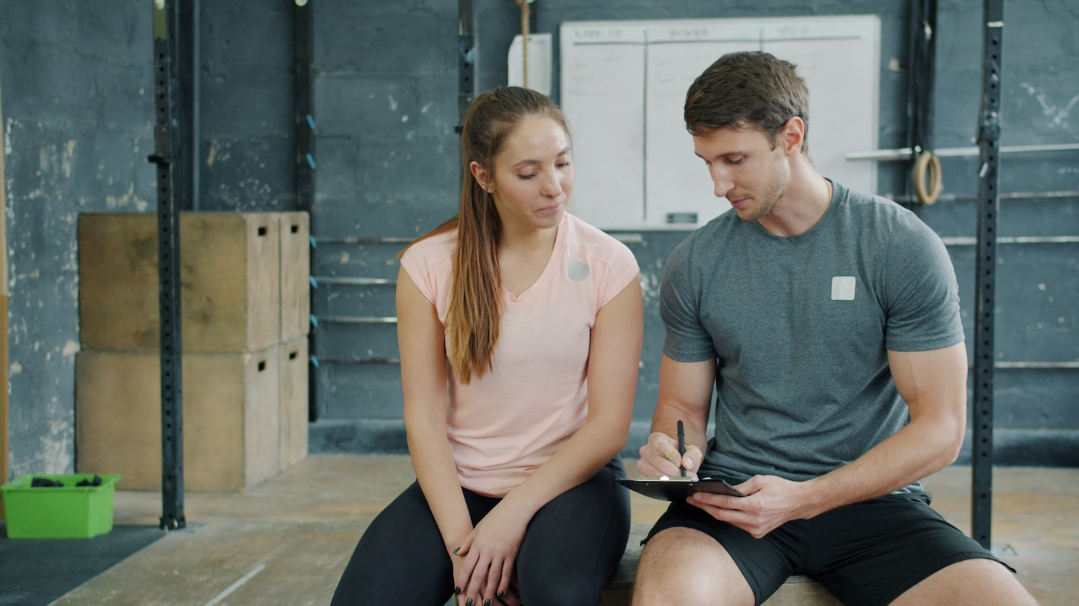
Prepared for | Program | Effective date
New Northstar members | Beginner coaching services | September 2026

Your first month: Use this guide to prepare for the starter assessment, understand each coaching session, track progress, and manage bookings with confidence.

NORTHSTAR FITNESS STUDIO | CLIENT WELCOME GUIDE / WELCOME
How to use this guide
Welcome to Northstar Fitness Studio. This guide gathers the information most new members need during their first month. Keep it nearby, add your appointment dates, and bring questions to your coach.

Your guide map
Section | What you will find | Best time to read
1. Before you begin | Forms, first-week actions, what to bring | Before your assessment
2. Coaching sessions | Arrival, structure, effort, and exercise changes | Before session one
3. Progress and communication | Tracking, reviews, questions, and feedback | During weeks one to four
4. Membership policies | Booking, cancellation, pauses, and privacy | Before booking recurring sessions
5. Safety and support | Pain, illness, urgent concerns, and scope | Before training
6. Quick reference | Contacts, checklist, and frequently asked questions | Whenever needed

Best first action: Complete the readiness form and book your starter assessment. Your coach uses both to recommend the safest useful starting point.

What good onboarding looks like
- You understand where to go, what to bring, and how long the appointment takes.
- Your coach understands your goals, schedule, experience, and relevant limitations.
- You leave with a realistic weekly plan and know how progress will be reviewed.
- You know how to ask questions, request an exercise change, and manage bookings.

NORTHSTAR FITNESS STUDIO | CLIENT WELCOME GUIDE / 1. BEFORE YOU BEGIN
A simple first-week plan

First-week checklist
- Complete the readiness and health-history form honestly and fully.
- Book a 45-minute starter assessment at a time you can attend without rushing.
- Download the Northstar member app and enable appointment reminders.
- Bring clean indoor shoes, water, comfortable clothing, and relevant instructions from a regulated health professional.
- Write down two goals: one outcome you care about and one weekly action you can control.

Your starter assessment
The assessment is a conversation and a low-pressure movement screen. It is not a test you can pass or fail. Your coach will ask about goals, available days, previous exercise experience, work demands, preferred activities, and any movement concerns.
Part | Approx. time | Purpose
Conversation | 10 minutes | Understand goals, schedule, experience, and preferences
Movement review | 15 minutes | Observe comfortable ranges and select useful starting options
Program walkthrough | 15 minutes | Practice key exercises and explain sets, repetitions, and effort
Next steps | 5 minutes | Confirm the first week, communication channel, and review date

What to bring
- Photo identification for account setup
- Clean indoor athletic shoes
- Water bottle
- Comfortable clothing
- Questions or relevant professional instructions

NORTHSTAR FITNESS STUDIO | CLIENT WELCOME GUIDE / 2. COACHING SESSIONS
What to expect each time you train

Session flow
- Arrive five minutes early, check in, and tell your coach about any change in how you feel.
- Complete the planned warm-up and practice the key movement for the day.
- Perform the main exercises at the agreed effort while your coach adjusts technique, load, or range.
- Finish with optional conditioning, mobility, or a short cooldown based on the session goal.
- Record the completed work and confirm the next appointment or independent session.

Understanding effort
Most working sets should feel challenging without requiring you to sacrifice control. A simple way to describe effort is to estimate how many good repetitions you could still complete.
Repetitions left | How it should feel | Typical use
4 or more | Comfortable and technical | Warm-ups, practice, recovery sessions
2-3 | Challenging but controlled | Most beginner working sets
1 | Very challenging | Occasional later-stage work with coach approval
0 | Maximum effort | Generally unnecessary for new members

Ask for a change: If an exercise causes sharp, worsening, or unfamiliar pain, stop and tell your coach. The goal can often be preserved by changing the movement, range, resistance, or speed.

If you arrive late
Your session still ends at the original time so the next member is not delayed. The coach will shorten the warm-up or reduce the number of planned exercises while keeping the most useful work.

NORTHSTAR FITNESS STUDIO | CLIENT WELCOME GUIDE / 3. PROGRESS AND COMMUNICATION
Make useful information easy to share

What to track
Item | What to record | Why it helps
Attendance | Sessions completed each week | Shows whether the plan fits your real schedule
Training work | Exercises, load, sets, repetitions | Makes gradual progression visible
Effort | Estimated repetitions left or session rating | Helps the coach choose an appropriate challenge
Recovery | Sleep, soreness, energy, unusual discomfort | Provides context for adjustments
Questions | Anything unclear before the next session | Keeps coaching specific and efficient

Four-week review
At the end of week four, your coach reviews attendance, exercise confidence, completed work, and your experience of the plan. The purpose is to improve the next month—not to judge a perfect or imperfect result.
- Keep: exercises and schedule choices that worked well.
- Change: movements, timing, or volume that created avoidable friction.
- Progress: one or two measurable training variables.
- Plan: the minimum week you can complete during a busy period.

How to contact the studio
Need | Best channel | Expected response
Routine booking question | Member app or email | Within one business day
Program clarification | Message your coach | Before the next scheduled session
Billing or membership question | Studio email | Within two business days
Urgent medical concern | Local emergency services or a regulated professional | Do not wait for a studio reply

PART TWO
MEMBERSHIP, SAFETY
& QUICK REFERENCE
Policies, practical safety guidance, contacts, and member action tools.
NORTHSTAR FITNESS STUDIO | CLIENT WELCOME GUIDE / 4. MEMBERSHIP POLICIES
Clear expectations for bookings and changes

Booking and cancellation
Appointments may be booked through the member app or by email. Cancel or reschedule at least 12 hours before the start time. A late cancellation may be counted as used unless the studio confirms an exception.

Membership pause
Submit a pause request at least seven days before the next billing date. Memberships may be paused for up to 30 days, twice per calendar year. Longer medical pauses may require separate review.

Respectful studio standard
- Return shared equipment to its marked location.
- Wipe down benches and handles after use.
- Use headphones for personal audio.
- Ask before recording anyone in the studio.
- Treat members and staff respectfully; harassment is not accepted.

Privacy and photographs
Training notes are used to deliver coaching services. Marketing photographs require a separate, voluntary release. Declining a photo request does not affect membership or coaching access.
Policy summary: Membership changes are confirmed in writing. Members receive the current terms at enrollment and are notified before a policy update takes effect.

NORTHSTAR FITNESS STUDIO | CLIENT WELCOME GUIDE / 5. SAFETY AND SUPPORT
Know when to pause, ask, or seek professional help

Before each session
- Tell your coach about illness, dizziness, unusual shortness of breath, new pain, or a recent injury.
- Follow medication and activity guidance provided by your prescriber or regulated health professional.
- Begin hydrated and bring water for the session.
- Use the exercise option and effort agreed with your coach rather than copying another member.

Pain and exercise changes
Muscle effort and temporary fatigue can be normal; sharp, sudden, worsening, or unfamiliar pain should not be ignored. Stop the activity and explain what you felt, where you felt it, and when it began.

Scope of service
Fitness coaching does not diagnose injuries, prescribe medication, provide emergency care, or replace medical treatment. When a concern falls outside coaching scope, the appropriate next step may be assessment by a regulated professional.

Urgent concerns
Emergency: For chest pain, severe breathing difficulty, loss of consciousness, symptoms of stroke, or another urgent concern, contact local emergency services immediately. Do not rely on email or app messaging.

Incident information
Record | Useful details
What happened | Activity, movement, equipment, and sequence
When and where | Date, time, and studio area
What was felt | Location, type, onset, and whether it changed
Immediate action | Exercise stopped, assistance provided, referral or follow-up

NORTHSTAR FITNESS STUDIO | CLIENT WELCOME GUIDE / 6. QUICK REFERENCE
Contacts, reminders, and common questions

Studio details
Item | Contact information
Address | 5010 Northstar Way, Edmonton, Alberta
Phone | (780) 555-0188
Email | hello@northstar-fitness.example
Hours | Monday-Friday 6:00 AM-8:00 PM; weekends 8:00 AM-2:00 PM
Booking | Member app or studio email

Before you leave home
- Appointment confirmed
- Indoor shoes packed
- Water bottle filled
- Coach updated about important changes
- Questions noted

Frequently asked questions

Do I need previous gym experience?
No. Foundation Coaching begins with equipment setup, basic movements, and comfortable effort selection.

Can an exercise be changed?
Yes. Your coach can adjust the movement, range, resistance, equipment, pace, or position while preserving the training goal.

What happens if I miss a session?
The cancellation policy applies. Contact the studio as soon as possible to ask about rescheduling options.
NORTHSTAR FITNESS STUDIO | CLIENT WELCOME GUIDE
QUICK REFERENCE CONTINUED

How quickly should I progress?
Progress depends on attendance, recovery, technique, and individual response. The plan changes gradually when completed work is controlled and repeatable.

Can I train independently?
Your coach can identify suitable independent sessions and explain which exercises, effort, and progression rules to use.
Your next step: Book the starter assessment, complete the readiness form, and bring this guide or your questions to the first appointment.

Personal action plan
Action | My plan | Review date
Book the starter assessment | Add date, time, and coach | Confirm 24 hours before
Choose a minimum training week | Add days and session type | Review after week two
Prepare one coaching question | Add the question you want answered | Bring to next session

Notes for my coach
Topic | Notes
Goal or priority | Add the outcome or habit that matters most right now.
Exercise preference | Add movements you enjoy, avoid, or want to understand.
Schedule constraint | Add travel, work, care, or recovery limits that affect the plan.

